Connect Five

This game is traditional Chinese board game, it has very simple rule to play. It does no matter how young and old can easy learn this quickly.

The game has two kinds of chess pieces which are white and black. Rule is who get 5 connected chess pieces first is the winner. However, it is not that simple. It has so many kinds of changes on that 18 by 18 board. This game is fully based on algorithms.

For the player vs player part, I have to switch the color every click. Then every click have to check the connections around the new click. It has 8 directions has to check. Just like the picture blow:

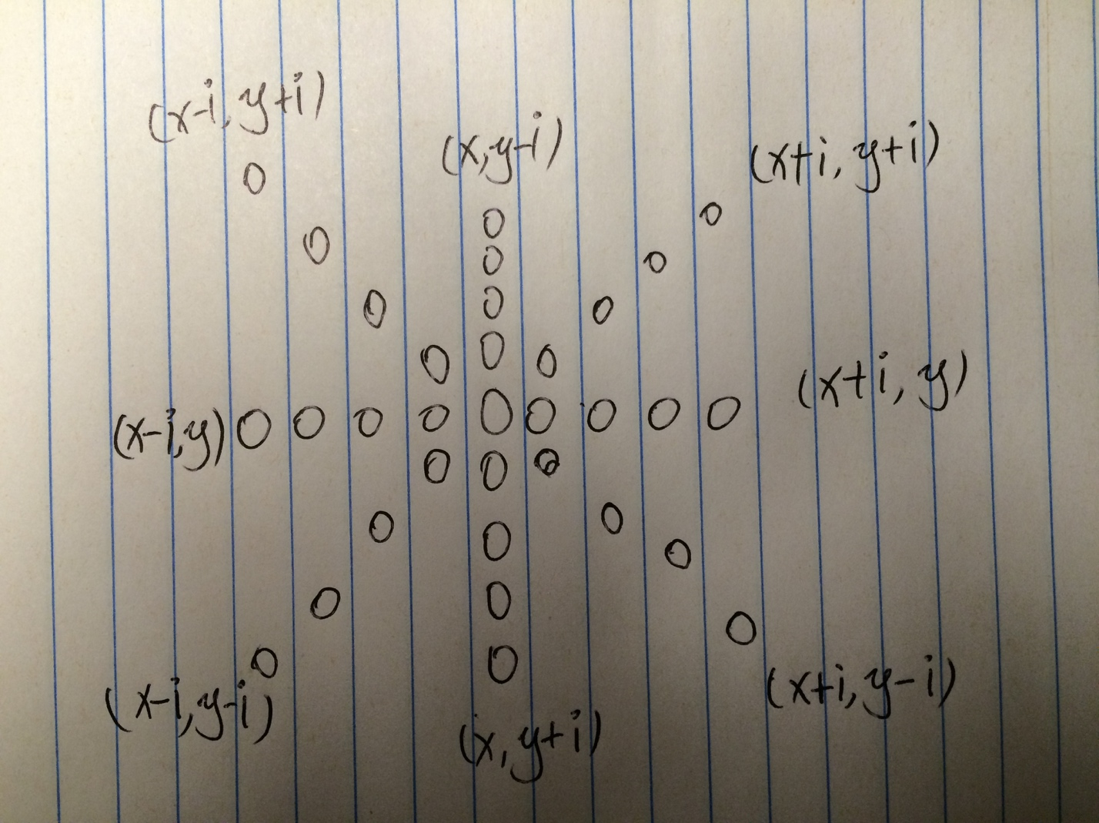

Around the new click, the check has to expand 4 blocks out. Then adding up the sum of two opposite directions. If the sum is great than 4 which means already won.

For the people Vs computer part, I create a new two dimensions’ integer array. This array is recording the best position for computer to put the chess piece. And it initialize as all zeros in the array. Then I apply a simple rule to increase the values in the array.

The rule is very simple:

1 chess piece x 2 ^1 = 2

2 chess pieces x 2^2 = 8

3 chess pieces x 2^3 =24

4 chess pieces x 2^4 = 64

the sores above will apply to each click. For example:

The first click of the game, all the position around the that chess piece will be 2. So for all 8 directions will be two. Then the computer will pick the first position of 2 to put its chess piece. after the computer putting the chess piece, whole array will be reset to 0 again.

The second click of player which is third click of the game. If there a 2 connective pieces will like the picture below:

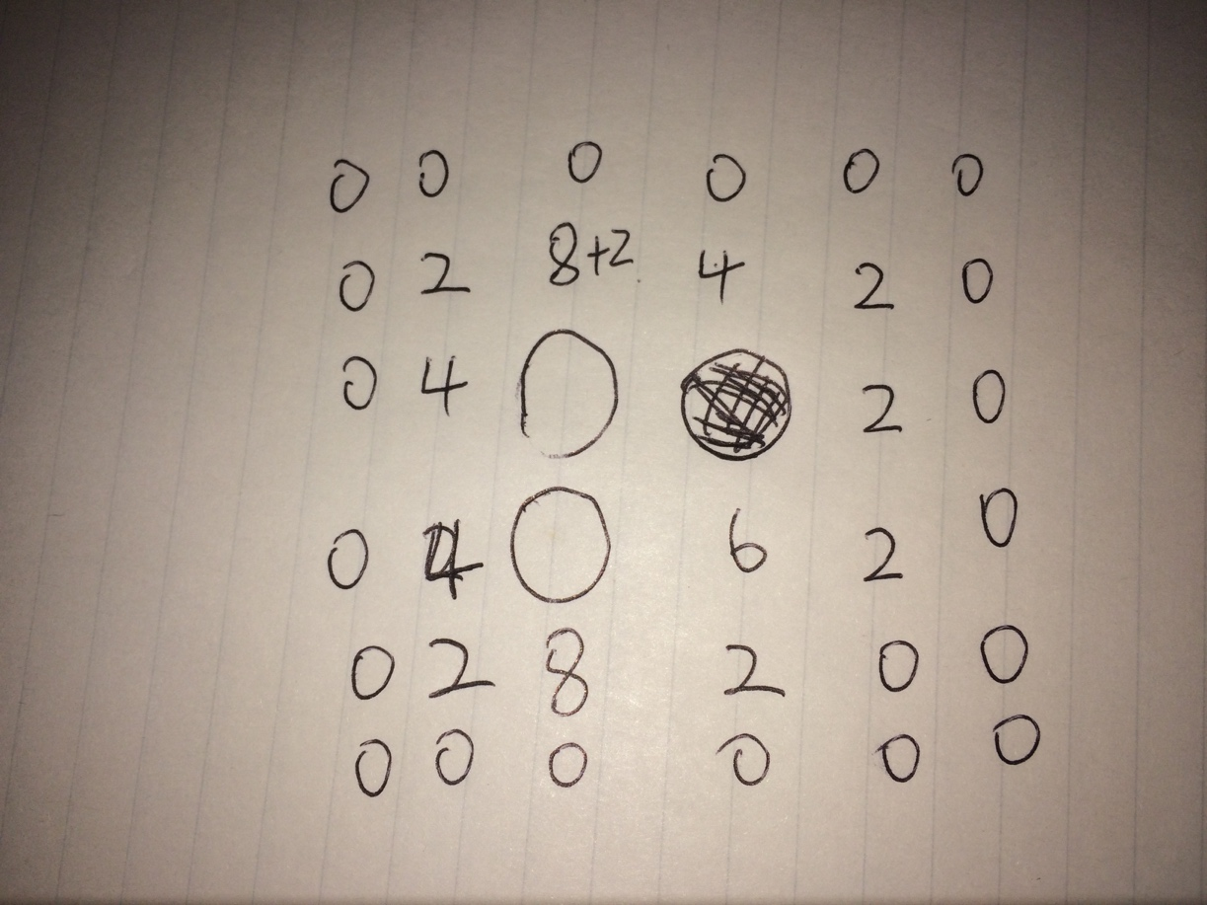

the greatest number will be next position for computer to put.